Customer Churn Analysis Using SQL
Introduction
Customer churn is one of the most critical challenges for subscription-based businesses such as telecommunications companies. Customer churn refers to the rate at which customers discontinue their service with a company. High churn rates directly impact revenue, profitability, and long-term customer relationships.
The objective of this project is to analyze customer churn patterns using SQL and identify key factors that contribute to customer attrition. By understanding the characteristics of customers who are more likely to churn, organizations can develop proactive strategies to improve customer retention and reduce revenue loss.
This project uses a telecom customer dataset containing demographic information, service usage details, and billing data for over 7,000 customers. SQL-based analytical techniques were applied to perform exploratory analysis, churn segmentation, and risk scoring.
Dataset Description
The dataset used in this project is the Telco Customer Churn Dataset, which contains customer information for a telecommunications company.
Dataset Size
Total Records: 7043 customers
Columns
Customer id
Gender
SeniorCitizen
Partner
Dependents
Tenure
Phone service
Contract
Payment Method
Monthly charges
Total charges
Churn

Data Preparation
The dataset was imported into PostgreSQL and stored in a raw table named telco_raw. Since the dataset initially contained all columns as text values, data cleaning and transformation steps were required to convert the data into appropriate data types.
Data Cleaning Steps
- Converted numerical fields such as tenure and charges into numeric formats.
- Replaced blank values in the TotalCharges column with NULL values.
- Created a churn flag variable where:
1 = Customer churned
0 = Customer retained
The cleaned dataset was stored in a table called telco_clean, which allowed for efficient analytical queries.
Exploratory Data Analysis
The first step in the analysis involved calculating key performance indicators (KPIs) to understand the overall customer base and churn behavior.
Key Metrics Calculated
Total number of customers
Total number of churned customers
Overall churn rate
Average tenure
Average monthly charges
Average total charges
These metrics provide a high-level overview of customer retention and help establish baseline performance indicators.
Churn Analysis by Customer Attributes
Churn by Contract Type
One of the most significant factors affecting churn is the type of contract a customer has with the company.
Customers with month-to-month contracts tend to have significantly higher churn rates compared to customers with one-year or two-year contracts. This indicates that customers without long-term commitments are more likely to discontinue the service.
Encouraging customers to transition to longer-term contracts could significantly reduce churn.
Churn by Payment Method
The analysis also examined how different payment methods affect churn behavior.
Certain payment methods showed higher churn rates, suggesting that payment convenience and billing structure may influence customer satisfaction and retention.
Companies can use this information to optimize payment options and offer incentives for preferred billing methods.
Churn by Internet Service
Internet service type also plays a role in customer churn patterns.
Customers using certain service types may experience higher dissatisfaction levels due to service quality, pricing, or performance, which can increase churn likelihood.
Tenure Cohort Analysis
Customer tenure is a key indicator of loyalty and retention.
Customers were grouped into tenure cohorts based on how long they had been with the company. The following cohorts were used:
0–6 months
7–12 months
13–24 months
25–36 months
37–48 months
49–60 months
61+ months
The analysis revealed that customers in the early tenure stages are significantly more likely to churn compared to long-term customers. This highlights the importance of strong onboarding and early customer engagement strategies.
Overall Customer Metrics
The first step of the analysis was to calculate key performance indicators (KPIs) related to customer churn. These metrics provide a high-level overview of customer behavior and service usage patterns.
The dataset contains a total of 7,043 customers, out of which 1,869 customers have churned, resulting in an overall churn rate of 26.54%.
The analysis also shows that the average customer tenure is approximately 32.37 months, indicating that many customers stay with the service for several years. The average monthly charge is $64.76, while the average total charges per customer are $2,283.30.
These metrics provide an initial understanding of the customer base and highlight that more than one-quarter of the customers have discontinued their services. This level of churn represents a significant business concern because customer acquisition costs are typically much higher than customer retention costs.
The KPI summary is shown in Figure 1.

Figure 1: Overall Customer KPI Summary
Churn Analysis by Contract Type
Contract type plays an important role in customer retention. Customers were grouped into three categories based on their contract type: month-to-month, one-year, and two-year contracts.
The results show that customers with month-to-month contracts have the highest churn rate at 42.71%, which is significantly higher than other contract types. In contrast, customers with one-year contracts show a churn rate of only 11.27%, while customers with two-year contracts have the lowest churn rate of 2.83%.
These results indicate that long-term contracts strongly improve customer retention. Customers who commit to longer contracts are less likely to leave the service.
From a business perspective, encouraging customers to move from month-to-month plans to long-term contracts could significantly reduce churn and improve revenue stability.
The results are illustrated in Figure 2.
Figure 2: Churn Rate by Contract Type
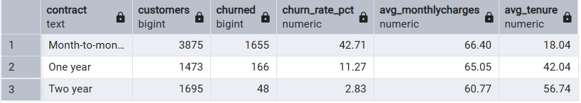
Churn Analysis by Payment Method
Payment method is another important factor that may influence customer retention. The analysis evaluated churn rates across four payment methods: electronic check, mailed check, bank transfer (automatic), and credit card (automatic).
The results show that customers using electronic checks experience the highest churn rate of 45.29%, which is significantly higher than other payment methods. Customers using mailed checks have a churn rate of 19.11%, while those using automatic bank transfers and credit cards have lower churn rates of 16.71% and 15.24% respectively.
This suggests that customers who use automated payment methods may be more engaged with the service, while electronic check users may represent a higher-risk customer segment.
Businesses can use this insight to encourage customers to adopt automatic payment methods, which may help reduce churn.
The results are shown in Figure 3.

Figure 3: Churn Rate by Payment Method
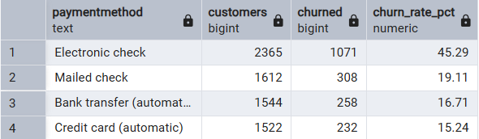
Tenure Cohort Analysis
Customer tenure was analyzed by grouping customers into different time-based cohorts to understand how churn behavior changes over time.
The analysis shows that customers in the first six months of service have the highest churn rate of 52.94%, indicating that new customers are the most likely to leave. Customers with 7–12 months of tenure show a churn rate of 35.89%, which is still relatively high.
However, as customer tenure increases, churn rates decline significantly. Customers with more than 61 months of tenure have a churn rate of only 6.61%, demonstrating that long-term customers are much more loyal to the service.
This pattern suggests that the first year of the customer lifecycle is the most critical period for retention strategies. Companies should focus on improving customer experience during the early stages of service adoption.
The tenure cohort results are presented in Figure 4.
Figure 4: Customer Churn by Tenure Cohort
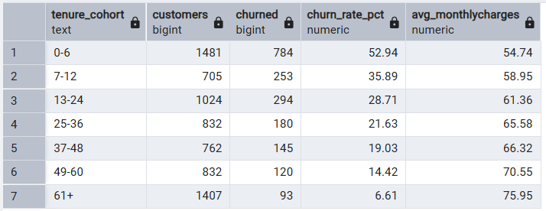

Customer Risk Segmentation
To better identify potential churn risks, a customer risk segmentation model was developed using SQL window functions.
Three key factors were used to determine churn risk:
- Customer tenure
- Monthly service charges
- Total lifetime value
Using SQL window functions (NTILE), customers were scored across these dimensions and categorized into three risk segments:
High Risk
Medium Risk
Low Risk
RESULTS:
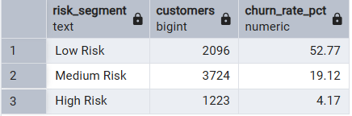
This segmentation allows businesses to focus retention efforts on the most vulnerable customer groups.
Key Business Insights
The analysis produced several important insights regarding customer churn behavior.
First, contract type is one of the strongest predictors of churn. Customers with month-to-month contracts churn at a significantly higher rate than those with long-term contracts.
Second, payment behavior also affects churn patterns. Customers using electronic checks show much higher churn rates compared to customers who use automatic payment methods such as bank transfers or credit cards.
Third, customer tenure plays a critical role in churn behavior. Customers in the early months of their subscription are far more likely to leave compared to customers who have remained with the service for several years.
Overall, the results indicate that early-stage customers and customers with flexible contract terms represent the highest churn risk segments.
Business Recommendations
Based on the analysis, several strategies can help reduce customer churn.
First, the company should encourage customers to transition from month-to-month contracts to longer-term contracts by offering discounts or loyalty incentives.
Second, customers using electronic check payments should be encouraged to adopt automatic payment options, which may improve customer retention and engagement.
Third, retention programs should focus on customers in their first year of service, since this period shows the highest churn rates.
Finally, predictive analytics models could be developed in the future to identify high-risk customers and proactively target them with personalized retention campaigns.

Conclusion
Customer churn analysis plays a vital role in helping businesses understand customer behavior and improve retention strategies.
This project demonstrated how SQL can be used to perform comprehensive churn analysis, generate actionable insights, and support business decision-making. By identifying the key drivers of churn and segmenting customers based on risk levels, companies can develop more effective retention strategies and improve long-term profitability.

